PIZZA SALES SQL QUERIES

- KPI’s

- Total Revenue
SELECT SUM(total_price) AS Total_revenue from pizza_sales
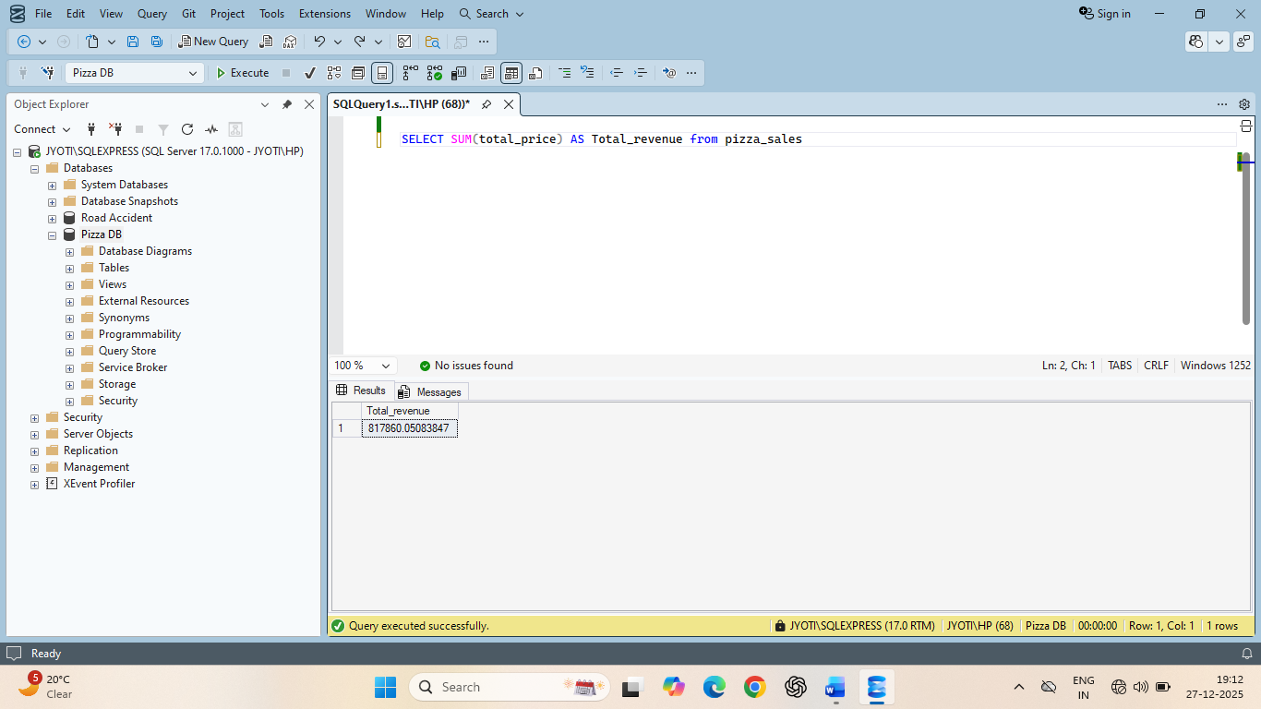

- Average Order Value

SELECT SUM(total_price) / COUNT(DISTINCT order_id) as Avg_order_value from pizza_sales

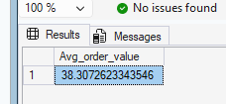

- Total Pizza Sold

SELECT SUM(quantity) as Total_pizza_sold from pizza_sales

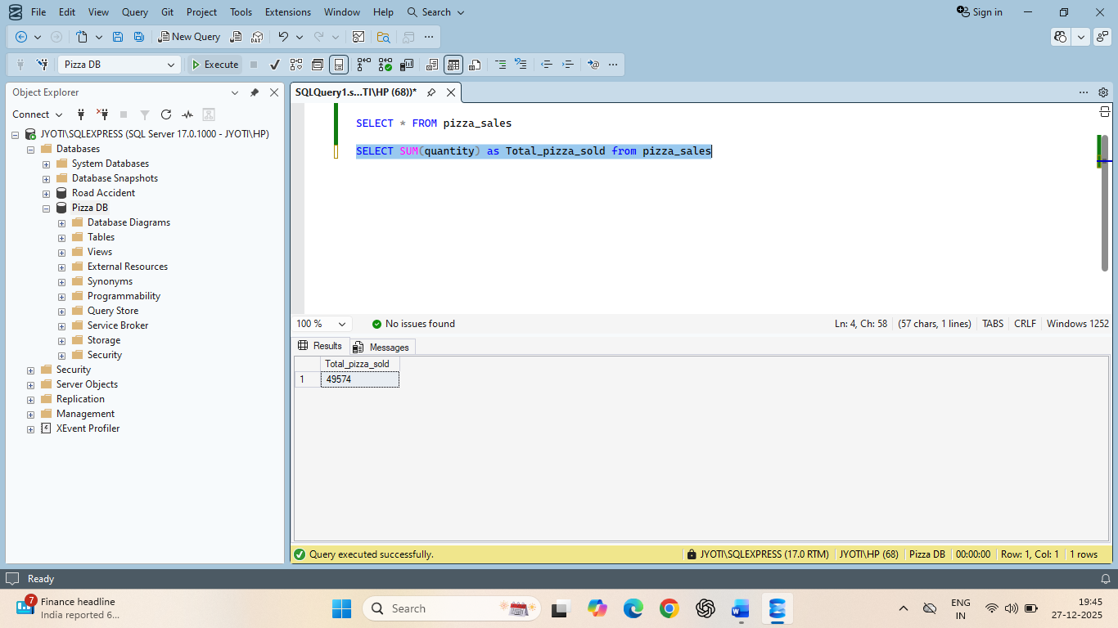

- Total Orders

SELECT COUNT (DISTINCT order_id) as Total_orders from pizza_sales

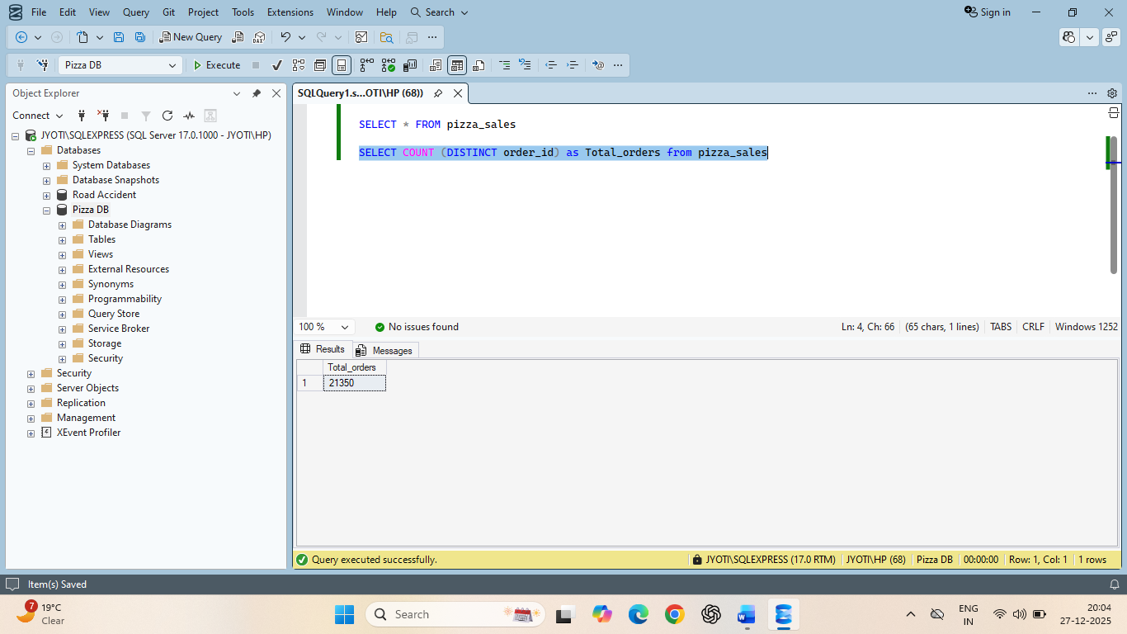

- Average Pizza Per Order

SELECT CAST(CAST(SUM(quantity) AS DECIMAL (10,2))/
CAST(COUNT(DISTINCT order_id) AS DECIMAL(10,2)) AS DECIMAL(10,2)) AS Avg_pizzas_per_order from pizza_sales

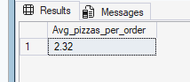

- Daily trends for Total orders
SELECT DATENAME(DW, order_date) as order_day,COUNT(DISTINCT order_id) AS Total_orders from pizza_sales
GROUP BY DATENAME(DW,order_date)
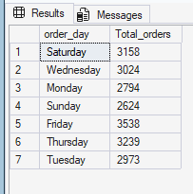
- Monthly Trend for Total Orders
SELECT DATENAME(MONTH, order_date) as MONTH_NAME, COUNT(DISTINCT order_id) AS Total_orders
from pizza_sales
GROUP BY DATENAME(MONTH,order_date)
ORDER BY Total_orders DESC

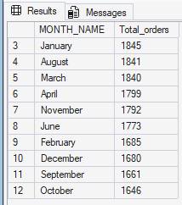

- % of sales by Pizza Category

SELECT pizza_category, sum(total_price) as Total_Sales, sum(total_price) * 100/
(SELECT sum(total_price) from pizza_sales WHERE MONTH(order_date) = 1) AS PCT
from pizza_sales
WHERE MONTH(order_date) = 1
GROUP BY pizza_category

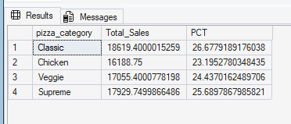

- % of sales by Pizza Size

SELECT pizza_size, CAST(sum(total_price) AS DECIMAL(10,2)) as Total_Sales, CAST(sum(total_price) * 100/
(SELECT sum(total_price) from pizza_sales WHERE DATEPART (quarter,order_date)=1) AS DECIMAL(10,2)) PCT
from pizza_sales
WHERE DATEPART(quarter, order_date) = 1
GROUP BY pizza_size
ORDER BY PCT DESC

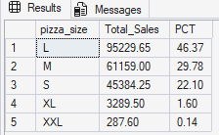

- Total pizza sold by pizza category

SELECT pizza_category,sum(quantity) AS Total_quantity_sold
from pizza_sales
WHERE MONTH(order_date) = 2
GROUP BY pizza_category
ORDER BY total_quantity_sold DESC

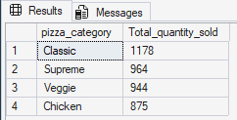

- Top 5 Best sellers by Total pizzas Sold

SELECT TOP 5 pizza_name, SUM(quantity) AS Total_pizza_sold
FROM pizza_sales
GROUP BY pizza_name
ORDER BY Total_pizza_sold DESC

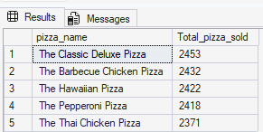

- Bottom 5 Best Sellers by Total Pizzas Sold

SELECT TOP 5 pizza_name, SUM(quantity) AS Total_pizza_sold
FROM pizza_sales
GROUP BY pizza_name
ORDER BY Total_pizza_sold ASC

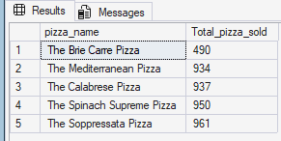
NOTE

If you want to apply the Month, Quarter, Week filters to the above queries you can use WHERE clause. Follow some of below examples

SELECT DATENAME(DW, order_date) as order_day,COUNT(DISTINCT order_id) AS Total_orders
FROM pizza_sales
WHERE MONTH(order_date) = 1
GROUP BY DATENAME(DW,order_date)

*More MONTH(order_date) = 1 indicates that the output is for the month of
January. Month(order_date) = 4 indicates output for month of April.

SELECT DATENAME(DW, order_date) as order_day,COUNT(DISTINCT order_id) AS Total_orders
FROM pizza_sales
WHERE DATEPART(QUARTER,order_date) = 1
GROUP BY DATENAME(DW,order_date)

*More DATEPART(QUARTER,order_date) = 1 indicates that the output is for the quarter 1. Month(order_date) = 3 indicates output for quarter 3.

